GRAPHICAL PASSWORD AUTHENTICATION

Gaurav Yadav
Department of CSE
SSIPMT
Raipur, India
gaurav.yadav@ssipmt.com

Upasana Khadatkar Assistant Professor
Department of CSE
SSIPMT
Raipur, India
u.mishra@ssipmt.com

Vivek Yadav
Department of CSE
SSIPMT
Raipur, India
vivek.yadav@ssipmt.com

Abstract— Passwords provide protection to electronic accounts and devices from unauthorized access. This paper proposes a graphical password authentication system that uses a series of images as a password to authenticate users and provides security from brute force, dictionary, key logger and shoulder surfing attacks.
Keys— Graphical Password Authentication

Introduction
Authentication is the process of verifying a user's identity. A series of identifying credentials and an incoming request are connected by the system. The provided credentials are compared to those kept in a database that contains data about the authorized user and is either located on the local operating system or an authentication server. In the majority of situations involving computer security, user authentication is a crucial element. It serves as the foundation for user accountability and access control. Alphanumeric passwords are the most frequently used user authentication techniques, even though there are numerous more. They are adaptable, simple to use, and easy to apply. Password must be easily recalled by the user while being difficult for the impostor to guess are the requirements for security. Most of the times, users make easily guessable or short text passwords, which becomes an easy target of brute force and dictionary attacks. A strong or long password is difficult to recall that may turn users to store their passwords in sticky notes that may lead them to direct theft. To overcome the limitation of alphanumeric password several techniques have been proposed, graphical password is one of them. Using graphical passwords, which use pictures (images) rather than alphanumeric passwords, is one suggested fix. Instead of having the user to type alphanumeric password, this can be accomplished by asking them to choose from images displayed to them in a specific order in a GUI. A graphical password authentication uses graphics(images) rather than letters, numerals, or other special characters as a password to authenticate users. Different implementations use different kinds of images and interact with them in different ways. A graphical password authentication system uses a series of images as a password rather than the combination of letters, numerals and other type of characters to authenticate.

Literature Review
In this journal, they explored many algorithms, approaches, and methodologies for graphical password authentication. These methods are divided into four groups: hybrid approaches; cued-recall methods; pure recall methods; and recognition-based methods. Graphical password schemes provide a means to make passwords that are easy for people to remember. The system's safety is extremely exceptional in this. Brute force searches and dictionary attacks are impossible. Images are easier to remember than long text and number sequences. They covered a variety of graphical password related topics to examine different attack patterns on graphical password authentication technique.
The graphical password system concept is the primary subject of this publication [2]. It is suggested to improve password authentication systems with the use of graphics (images). The use of cued click points for authentication purposes supports it. The user's engagement with a succession of five images is the core idea behind this system. This system's main objective is to increase security using user-friendly methods that are more difficult for hackers to guess. The most excellent replacement for text passwords is an authentication system that uses graphics. The best replacement for the outdated graphical password system is cued click point (CCP). Pass Matrix is a cutting-edge authentication solution that uses graphical passwords to fend off shoulder surfing assaults [3]. Even if an attacker employs numerous camera-based methods, the Pass Matrix does not provide any way to how to discover or narrow down the password. It contains rotating horizontal and vertical bars that cover the entire range of pass photos. In this study, a graphic authentication system using a pass matrix was developed [4]. Computer security and privacy commonly use authentication-based passwords. The majority of conventional passwords are made up of letters and digits. That is immediately recognizable by those who are not authorized. Attacks that use shoulder surfing start with identification. Human error, such as selecting wrong passwords and entering passwords incorrectly, is a weak point in the process of authentication. People can access these applications anytime, anywhere, and on a variety of devices thanks to the proliferation of online and mobile applications. Pass Matrix presented to solve these issues.
They addressed the issue of password failing in this publication [5]. Passwords are used by almost all websites. This sites confirm that a user, who is trying to access an account is the account holder. However, passwords may be forgotten, lost, or stolen, websites must be capable enough to identify a user, who is unable to provide the correct password. For that users need to provide some sort of secondary authentication to demonstrate their identity and regain access to their accounts. There are numerous secondary authentication methods that websites can use. The article examines secondary authentication methods, highlighting the value of building a toolbox of techniques that satisfy the security and dependability requirements of users.

Proposed Methodology
Everything is happening online as a result of the rapid digitalization of the globe brought on by rising technology breakthroughs. As more and more activities move online, the potential for cybercrimes and privacy violations is increasing. Your data is greatly protected by passwords on both online and offline platforms. The standard authentication technique for accessing our accounts is passwords. A variety of authentication techniques are available to users to protect their accounts.
•Token based authentication covers ATM(Debit/Credit) card.
•Knowledge based authentication covers Text based authentication and image based authentication.
•Biometric authentication methods include facial recognition, iris scanning, and fingerprint verification.
• In recognition-based authentication, a user is shown a series of images and asked to select the one he has previously registered with. Users can choose from a wide selection of photos when creating passwords. Users must choose the pre-selected image from the range of images displayed to them in
order to log in We proposed a graphical password system that provide more security than alphanumeric password. During the registration, the system will display a 3*3 grid consisting of 9 images for passwords. Every picture has a numerical value assigned to it. A user creates a graphical passcode by choosing 3 images from a 3*3 grid. In graphical password, During the login, to authenticate himself/herself, the user must choose correct series of images to successfully log in.

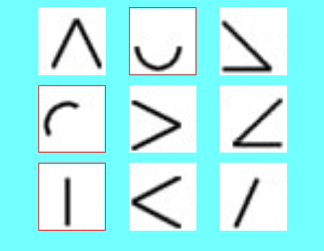

Fig 1:- Grid of 3x3 images

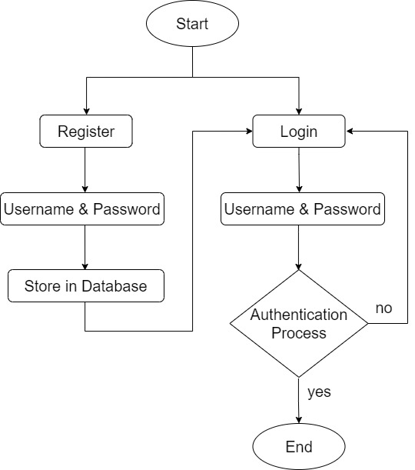

Fig. 2:- Flow Chart

Scope In The Future
A password should be easy to remember and hard to guess by the attacker. Supporting users in choosing a stronger password is a key usability objective of an authentication system. The system given passwords are strong but challenging to remember, and user created memorable passwords are simple for an attacker to guess. Therefore, researchers in the current era have investigated several alternative techniques and come to an end that graphical passwords are the highly preferred verification scheme. So, alphanumeric text-based passwords can be replaced by graphical passwords. Graphical passwords require users to select a set of images to verify their identity. It is the most preferred authentication method because it overcome the shortcomings that the majority of the existing authentication systems have. As alphanumeric password can be stolen by dictionary, brute force, and shoulder surfing attacks.

Result
Alphanumeric passwords are either difficult to remember or easy to guess when using conventional alphanumeric text based password authentication. Additionally, because it can be challenging to memorize a lot of passwords, users typically use the same password for all of their accounts. A study found that the human brain is better at memorizing visual information than alphanumeric characters. As a result, the drawback of alphanumeric passwords is overcome by graphical passwords. In comparison to other conventional password schemes, it offers greater security.
• Brute force attacks: Until the right password or passphrase is determined, the attacker iteratively tests every possible combination. The user will receive notification through email along with a new login link once they have used up all of their attempts. Additionally, future online login for that user account is disabled. Additionally, it informs the legitimate user about the attacker.
• Dictionary Attacks:-These types of attacks use a predefined set of combinations of values. Even though the images used at registration may have an impact on the password combination selected, the images in the grid always vary from the database. Thus the occurrence of the same grid which was at the time of selecting the passwords
is very low.
• Key loggers:-Key loggers covertly record keystrokes and send them to a remote server, but if spyware wants to monitor mouse movements, it can do so, and the attacker won't know which portion of the graphical password is being controlled by the mouse.
• Shoulder Surfing: This technique involves peering over the target's shoulder to collect details such as passwords, personal identification numbers (PINs), and other private information. When the users choose password during login, the technique we use make password invisible on the screen. Because of this, it is very difficult for the attacker to see the images that the user clicks on the grid.

Conclusion
Alphanumeric passwords are used by the majority of programs and websites to verify users. Unfortunately, this lacks security and leaves the system open to several types of attacks. Although alphanumeric passwords appear secure in theory, most users will wind up creating straightforward, widely used passwords that are regularly reused across many programs or accounts. This can be exploited by bot assaults or hackers who then conduct dictionary attacks, attempt to brute force the password, or utilize other techniques to compromise user accounts. Standard alphanumeric passwords can be replaced with graphical passwords, which are more secure and don't dramatically reduce usability. We can eliminate the issue of keystroke logging and obtain security from social engineering and dictionary assaults by using graphical password authentication. This method of user authentication also calls for user involvement, which serves to confirm that a user is a real person rather than using the CAPTCHA.

References
- Saranya Ramanan, Bindhu J S,” A Survey on Different Graphical Password Authentication Technique”, International Journal of Innovative Research in Computer and Communication Engineering, Vol. 2, Issue 12, December 2014.
- Amol Bhand, Vaibhav desale, Swati Shirke, Suvarna Pansambal (Shirke), “Enhancement of Password Authentication systemusing Graphical Images”. 2015 International Conference on Information Processing (ICIP) Vishwakarma Institute of Technology. Dec 16-19, 2015.
- Hung-Min Sun,Shiuan-Tung Chen,Jyh-Haw Yeh and Chia-Yun Cheng, “A Shoulder Surfing Resistant Graphical Authentication System” DOI10.1109/TDSC.2016.2539942IEEE.
- Sarojini, Priya, Bhuvaneshwari, “Graphical Authentication System Using Pass Matrix“.International Journal of Computer Trends and Technology(IJCTT) Special Issue April – 2017.
- Robert Reeder, Stuart Schechter, “When the Password Doesn’t Work: Secondary Authentication for Websites”. IEEE Security & Privacy (Volume: 9, Issue: 2, March-April 2011).
- William Stallings and Lawrie Brown. Computer Security: Principle and Practices. Pearson Education, 2008.
- D. Davis, F. Monrose, and M. K. Reiter, "On user choice in graphical password schemes," in Proceedings of the 13thUsenix Security Symposium. San Diego, CA, 2004.
- Lashkari, A. H., Gani, A., Sabet, L. G., & Farmand, S. (2010). A new algorithm on Graphical User Authentication (GUA) based on multi-line grids. Scientific Research and Essays, 5(24), 3865–3875.
- Aakansha Gokhale, & Vijaya Waghmare. (2013). Graphical Password Authentication Techniques: A Review. 7.
- K. Renaud, “Guidelines for designing graphical authentication mechanism interfaces,” International Journal of Information and Computer Security, vol. 3, no. 1, pp. 60–85,June 2009.
- A.De Angeli, L. Coventry, G. Johnson, and K. Renaud, “Is a picture really worth a thousand words? Exploring the feasibility of graphical authentication systems,” International Journal of Human-Computer Studies, vol. 63, no. 1-2, pp. 128–152, 2005.
- K.-P. L. Vu, R. Proctor, A. Bhargav-Spantzel, B.-L. Tai, J.Cook, and E. Schultz, “Improving password security and memorability to protect personal and organizational information,” International Journal of Human-Computer Studies, vol. 65, pp. 744–757, 2007.

